How Do I Locate That Earthquake's Epicenter?
To figure out just where that earthquake happened, you need to look at your seismogram and you need to know what at least two other seismographs recorded for the same earthquake. You will also need a map of the world, a ruler, a pencil, and a compass for drawing circles on the map.
Here's an example of a seismogram:
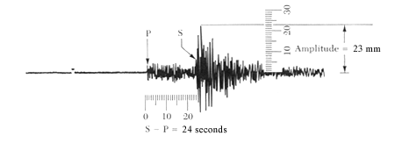
Figure 1 - Our typical seismogram from before, this time marked for this exercise (from Bolt, 1978).

One minute intervals are marked by the small lines printed just above the squiggles made by the seismic waves (the time may be marked differently on some seismographs). The distance between the beginning of the first P wave and the first S wave tells you how many seconds the waves are apart. This number will be used to tell you how far your seismograph is from the epicenter of the earthquake.
Finding the Distance to the Epicenter and the Earthquake's Magnitude
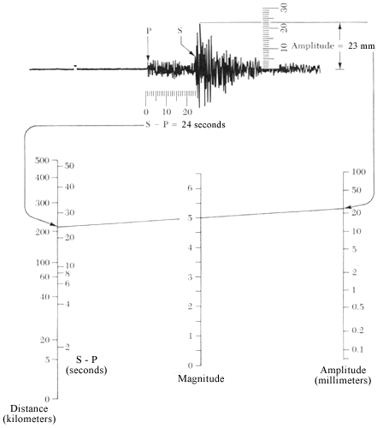  Figure 2 - Use the amplitude to derive the magnitude of the earthquake, and the distance from the earthquake to the station. (from Bolt, 1978) | - Measure the distance between the first P wave and the first S wave. In this case, the first P and S waves are 24 seconds apart.  - Find the point for 24 seconds on the left side of the chart below and mark that point. According to the chart, this earthquake's epicenter was 215 kilometers away.  - Measure the amplitude of the strongest wave. The amplitude is the height (on paper) of the strongest wave. On this seismogram, the amplitude is 23 millimeters. Find 23 millimeters on the right side of the chart and mark that point.  - Place a ruler (or straight edge) on the chart between the points you marked for the distance to the epicenter and the amplitude. The point where your ruler crosses the middle line on the chart marks the magnitude (strength) of the earthquake. This earthquake had a magnitude of 5.0.
Finding the Epicenter
You have just figured out how far your seismograph is from the epicenter and how strong the earthquake was, but you still don't know exactly where the earthquake occurred. This is where the compass, the map, and the other seismograph records come in.
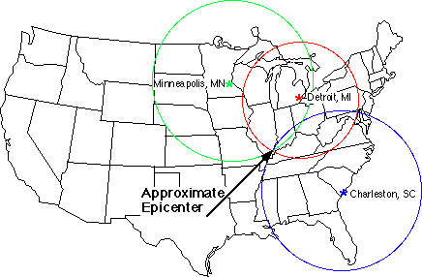  Figure 3 - The point where the three circles intersect is the epicenter of the earthquake. This technique is called 'triangulation.' | - Check the scale on your map. It should look something like a piece of a ruler. All maps are different. On your map, one centimeter could be equal to 100 kilometers or something like that.  - Figure out how long the distance to the epicenter (in centimeters) is on your map. For example, say your map has a scale where one centimeter is equal to 100 kilometers. If the epicenter of the earthquake is 215 kilometers away, that equals 2.15 centimeters on the map.  - Using your compass, draw a circle with a radius equal to the number you came up with in Step #2 (the radius is the distance from the center of a circle to its edge). The center of the circle will be the location of your seismograph. The epicenter of the earthquake is somewhere on the edge of that circle.

4. Do the same thing for the distance to the epicenter that the other seismograms recorded (with the location of those seismographs at the center of their circles). All of the circles should overlap. The point where all of the circles overlap is the approximate epicenter of the earthquake.

